**Executive Summary**

The Pandemic Control and Management Support (PCMS) is an initiative for proffering better emergency response mechanisms during pandemic situations. This paper has considered the old system, the current system, and the new envisaged system. The computerized perspective to advancing the current system has been considered while favouring a cloud-based approach. The methodology for such a computing architecture is also reviewed. On the whole, a comprehensive review of the issues and problems inherent in the existing and future orders is also examined. The paper is only a preamble to other segments of an entire PCMS project for hypothetical two-year duration.

**Introduction**

A pandemic is the outbreak of a deadly disease that spreads to and infects people so fast that it becomes prevalent over a whole country or the world before vaccine administration. The criticality of a pandemic is such that governments and health institutions across the world are usually handicapped until a vaccine is discovered. Efforts to mitigate the effects of a pandemic at the early stage have necessitated the need for a computerized Pandemic Control and Management Support (PCMS) system (Research Guide).

The hypothetical PCMS system being considered is a typical two-year project to design, research, and produce a support system for aiding either the government or the citizens with comprehensive pandemic data. These data shall include, amongst other things, the pandemic origin and biological family, the demographic distribution of those infected, etc. They shall also include warning signs, advice, and necessary care arrangement for the citizens (Research Guide).

However, when considering such a system and associated incidental costs, serious attention must be given to the computing architecture and resources required to drive the scheme. Typical questions might include: should the system preference be based on bare-metal systems or co-located systems that will unavoidably involve upfront acquisition of and investment in hardware and software? Or, better still, a system that makes possible the adoption of a system architecture that makes possible the payment for computing resources on per use case basis?

Cloud computing resources are ideal for a PCMS project because they make possible location-independent facilities that are also affordable.

.

**The Purpose of the Project**

The PCMS will serve the purpose of an emergency response initiative that effectively equips health care experts with all necessary information for proactive measures. This is because, so far, pandemic influenza has posed a major global health hazard to governments all over the world. Based on the PCMS and other similar initiatives, the Australian Government and the broader Australian health sector, for example, is strategically equipped for emergency response pandemic influenza crises. The current COVID-19 pandemic experienced all over the world, which broke out in China, has defied all measures because non-viable PCMS programs adaptable to the COVID-19 influenza.

**The Issues**

According to Alexander Capron of the University of Southern California, a variety of ethical approaches to pandemic planning needs to be examined in terms of both the content of policies to be applied and the processes by which they are established and implemented (Reference Guide). Answers must be provided to questions including: What are the implications of pandemic influenza for human rights? How can unhindered access to health care be guaranteed? What are the obligations of and to health-care workers? What obligations should the masses expect from their countries and inter-governmental organizations? Under a PCMS initiative, these issues need be adequately addressed and policy paper(s) articulated anticipatory to the onset of pandemics (Reference Guide). A key issue in pandemic management is about handling preference or priority of who gets healthcare attention first. Should the old and sickly go first or the security officials or the primary healthcare providers or the privileged or the leaders?

**The Benefits**

Because a global pandemic influenza will affect every country, the world needs a standardized and coordinated approach to international information dissemination that is essential for effective crisis management at international levels. Thus, the benefits of a robust computerized PCMS system consist in readily available and shareable information at a global level. These benefits shall amongst other things include:

* + The rapid accumulation of critical clinical, epidemiological and virological data about the new disease.
  + The enablement of health care providers and public health authorities to modify their strategies for case management, community mitigation, and health resource allocation.
  + Easily and efficiently dispersing the workload among the first affected countries.
  + The minimization and mitigation of the impacts of uncoordinated intelligence regarding the pandemic.
  + Equipping the WHO to serve as a stabilizing and credible resource for pandemic control.

With a computerized pandemic control and management system, an undisrupted flow and collection of intelligence courtesy of individual countries will reinforce a global assessment of the situation. Any misinformation or lack of information at all levels will facilitate unnecessary loss of lives, inadequate resource allocation, spread of damaging rumors, and ultimately misdirected efforts.

**The Methodology**

# Viable methods for successful emergency response campaigns against pandemics are such that must leverage technology. This is because technologies and surveillance systems are integral and constantly evolving to bolster the supports of public health in response to outbreaks or some other public health scenarios. Only technologies and surveillance systems that are pervasive and cost-friendly will present viable options for situational awareness, early event detection, enhanced surveillance, identification and management of exposed persons, response monitoring, etc. Thus, it has been concluded that only cloud-based simulation architecture shall satisfy the above for pandemic influenza simulation. This is because cloud-based solutions are scalable, accessible from any part of the world, and are flexible to accommodate cost requirements.

# Cloud Computing Platforms and the Google Cloud Platform

# Although many cloud platforms exist commercially such as Amazon E2, Microsoft Azure, etc., the Google Cloud Platform (GCP) shall be embraced here. The GCP option is as a result of Google’s leading research roles in the use of containerization techniques, Kubernetes engine, data analytics, big data, and ML for handling complex data structures of geometrical proportions simultaneously from different parts of the world. In simulating pandemic situations, a good practice shall be to explore short-term rental of virtual machines based on use cases and owing to the need for either scaling up or down of execution resources during ongoing outbreaks. Additionally, regardless of the adopted choice, there is also the liberty to pay for time slices regarding services and resources without the need for huge upfront capital investments on hardware and software acquisition.

# With internet-based cloud surveillance, activities are event-based rather than the traditional passive types that rely on routine reporting by healthcare systems. Also, with the advancement in computing technology and software engineering, methodologies for wide epidemic and pandemic simulations have become possible.

A sample cloud-facilitated case management scenario for epidemic and pandemic event measurement, monitoring, storage, and retrieval architecture is as shown in the diagram below.

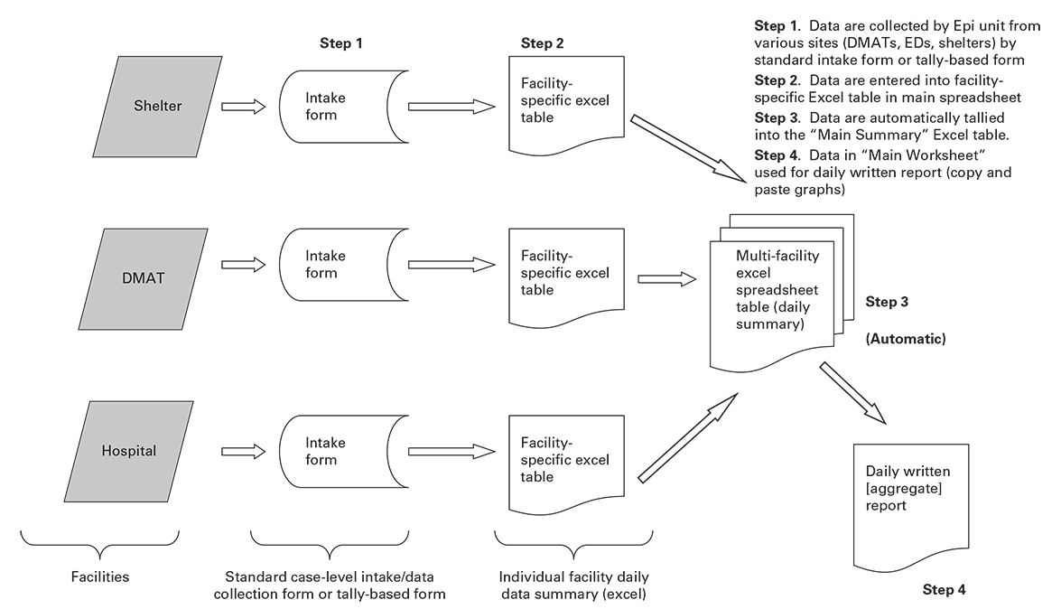

**Source:** Florida Department of Health, Bureau of Epidemiology. County health department epidemiology hurricane response toolkit. Updated April 20, 2015, p. 19.

**Recommendations**

Based on documented trending of pandemic influenza scenarios, the following action points are hereby recommended:

* + **planning and coordination**

This takes care of envisaging the leadership and coordination of events necessary across regions.

* + **situation monitoring and assessment**

In this scenario, information and data regarding the pandemic risks before occurrence are collected, interpreted, and disseminated to monitor the pandemic characteristics.

* + **reducing the spread of disease**

This refers to concerted efforts required to checkmate rapid and uncontrollable spreading of the disease through the enforcement of “social distancing” as well as inter and intra-city or international lockdown measures.

* + - **continuity of health care provision**

Planning for the responsive building of isolation centres in proportion to the escalation of the pandemic is necessary.

* + - **communications.**

On-the-spot monitoring and reporting of the exact situations from different regions through effective communications cannot be over-emphasized. This will enhance informed decisions and appropriate actions from healthcare service providers.

**The Current PCMS System**

Current Pandemic Control and Monitoring Systems cannot be said to have completely explored proactive behaviors in terms of rapid responsiveness to spreads and enabling technologies such as cloud hosting. The COVID-19 pandemic is an alarming case in hand. The COVID-19 virus has exposed the weakness of mankind’s technology, research, and science in swift and practiced response. Who would have thought that China, the US, Italy, the UK, Iran, and a host of other advanced societies would be worst hit at this time? While some school of thought may readily churn out conspiracy theories behind the COVID-19 emergence, the one thing that stands out is the fact that hitherto pandemic control and management support systems are heavily flawed and would require urgent overhauling.

* The Issues

Several issues can be spotted in the current PCMS system. For example, why was there no predictive model for anticipating situations like this with appropriate response measures? Why must it take the world this long without yet discovering a COVID-19 vaccine? Could there be paranormal reasons for the outbreak of this pandemic? Considering the antecedents and life cycles of COVID-19 predecessors such as SARs and Ebola, what are we expecting with the present strain of the corona virus? What sort of intervention is required to beef up the capacities of the healthcare practitioners both to adequately protect themselves as well as the society?

* The Problems

With news reports from all over the world, the COVID-19 pandemic has opened the lid on myriads of social problems. One consequence of a global scale of “social distancing” is that organizations will suspend routine jobs which lead to corporate and economic recessions. Recessions also result in job cuts and losses that lead to frustration, bitterness, poverty, and famine. Another consequence is that when business owners and commercial entities stay away from their centers, street urchins take laws into their hands with the banditry and looting of stores for example. Enforcing lockdowns without governmental provisions of adequate palliatives during the lockdowns breeds hunger and other examples of armed banditry.

**The Future PCMS System**

The methodology of implementation for future PCMS systems must be rigidly built around proactive mindset and strategies. Scalable, flexible, and cost-adaptive options offered by current cloud-based solutions must also be often examined and overhauled for improvements. A reliable PCMS system must be anticipatory and well equipped for needed actions.

* The Issues

For future PCMS systems to be successful, they must, among other things, provide positive answers to the issues of anticipatory models with readiness abilities, shortest possible times-to-market pandemic vaccines, timely and robust solutions leveraging the experiences from predecessors to contemporary pandemic.

* The Problems

Future PCMS systems must target addressing all the problems currently posed by the COVID-19 outbreak as well as simulate other possible scenarios and counter-measures.

**Conclusion**

Given the numerous advantages to using services, applications, and resources hosted in the cloud, there is no doubt that a cloud architecture will be ideal for achieving the goals of a PCMS system. Viral cases such as the current pandemic (code named COVID-19) closely mimic nuclear chain reaction patterns of spreading so fast before mitigatory measures can be thought out. This informs the decision for a computerized pandemic control and management support system project over a 2-year span for designing, researching, and creating a surveillance system as aids equipping either the government or the citizens with comprehensive pandemic data. This paper x-rays current and future PCMS systems, their issues as well as their problems and proffered solutions.

In this section, attention has been focused on the purpose of such a PCMS system to include an emergency response initiative which will effectively and ultimately equip health care experts as well as governmental agencies with all necessary information for proactive measures. Also, a number of ethical issues has been thrown up by pandemic influenza (such as the current COVID-19 case). Issues such as a diverse ethical approach to pandemic planning, the implications of pandemic influenza for human rights, how to guarantee unhindered access to health care during pandemics like this, the obligations of and to health-care workers, etc.

The benefits of such a successful PCMS system shall include the empowerment of the health care providers and public health authorities to modify their strategies for case management, community mitigation, and health resource allocation.

Also, in considering how a cloud-based approach will greatly enhance the methodology of such a solution, the Google Cloud Platform (with Google as the OEM) was considered for its distinguishing innovative technologies. Lastly, recommendations examined include those revolving around planning and coordination the PCMS, the situation monitoring and assessment, efforts for reducing the spread of the disease, continuity of healthcare provision, and effective communication of real-time events.

# Reference List

# Research Guide: TECH902 Management of Computer Systems and Plans, Assignment 2

# 

Lee VJ, Lye DC, Wilder-Smith A. *Combination strategies for pandemic influenza response - a*

*systematic review of mathematical modeling studies*. BMC Med. 2009 Dec 10;7:76.

Timpka T, Eriksson H, Gursky EA, Strömgren M, Holm E, Ekberg J, Eriksson O, Grimvall A,

Valter L, Nyce JM. *Requirements and Design of the PROSPER Protocol for Implementation of Information Infrastructures Supporting Pandemic Response: a Nominal Group Study*. PLoS One. (in press)

Resolution WHA 56.19 *Prevention and control of influenza pandemics and annual epidemics*.

In: Fifty-sixth World Health Assembly, Geneva 19-28 May, 2003

Ethical considerations in developing a public health response to pandemic influenza

(WHO/CDS/EPR/GIP/2007.2),World Health Organization, 2007.

Resolution WHA 58.5 *Strengthening pandemic influenza preparedness and response*. In: Fifty-

eighth World Health Assembly, Geneva 16-25 May, 2005. (WHA58/2005/REC/1).

WHO Interim planning guidance for rapid containment of the initial emergence of pandemic

influenza. <http://www​.who.int/csr​/disease/avian_influenza​/guidelines/draftprotocol​/en/index.html> accessed 02 May 2020

Pandemic Influenza Preparedness and Response,

<https://www.ncbi.nlm.nih.gov/books/NBK143063/>, accessed 02 May 2020

Ethical and Legal Considerations in Mitigating Pandemic Disease: Workshop Summary,

<https://www.ncbi.nlm.nih.gov/books/NBK54169/>, accessed 02 May 2020

# A Cloud-Based Simulation Architecture for Pandemic Influenza Simulation, <https://www.ncbi.nlm.nih.gov/pmc/articles/PMC3243184/>, accessed 02 May 2020